Session:-1

Question :-1. Write a short paragraph in your own words defining what a 'program' is and give one real-life example from any app you use daily (like Instagram, Zomato, or Paytm).
Answer
:- A program is a set of instructions given to a computer to perform a specific task. The computer follows these instructions step by step to produce the required result.
Example :- I use Instagram every day. When I open Instagram, the program shows my feed, reels, messages, and notifications automatically according to its instructions.

Question :-2. List three popular programming languages you have heard of, and for each, mention whether it is usually compiled, interpreted, or can be both.<br><br><em><strong>Hint:</strong> Think of languages like Java, Python, and JavaScript.</em>
Answer
Programing language compiled/interpreted
1:- C. :- compiled
2:-python. :-interpreted
3:-java. :-Both (c/I)

Question :-3 Draw a flowchart (on paper or using any online tool) for the process of booking a movie ticket on BookMyShow, starting from opening the app to receiving the booking confirmation.
Answer :-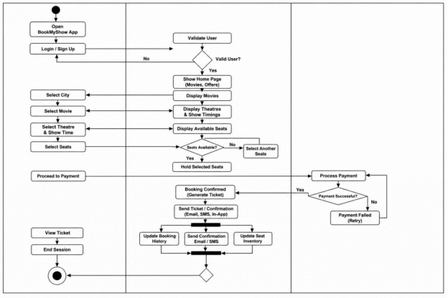

Question :-4 Write down the steps (as an algorithm, using simple numbered instructions) for ordering food on Swiggy — from opening the app to completing payment.
Answer
:- Start.
:-Open the Swiggy app.
:-Log in to your account.
:-Enter or confirm your delivery location.
:-Search for a restaurant.
:-Select the restaurant.
:-Choose the food items.
:-Add the items to the cart.
:-Review your order.
:-Click Proceed to Payment.
:-Select a payment method
:-Complete the payment.
:-Receive the order confirmation.
:-Wait for the food to be delivered.
:-En

Session:-2
Question :-1 Install GCC on your computer and verify the installation by running gcc --version in your terminal or command prompt.
Answer
rathod vijay@DESKTOP-154A0NA ~ $gcc --version
gcc.exe (Rev5, Built by MSYS2 project) 16.1.0
Copyright (C) 2026 Free Software Foundation, Inc.
This is free software; see the source for copying conditions. There is NO
warranty; not even for MERCHANTABILITY or FITNESS FOR A PARTICULAR PURPOSE.
rathod vijay@DESKTOP-154A0NA ~ $
:- I installed the GCC compiler on my computer successfully. I verified the installation by running:
gcc --version
The command displayed the GCC version, confirming that GCC was installed successfully.

Question :-2 Open VS Code or DevC++ and create a new file named hello.c. Write a C program that prints "Hello, Instagram World!" to the console.
Answer:- Input
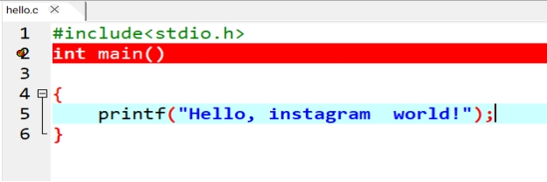
Out put
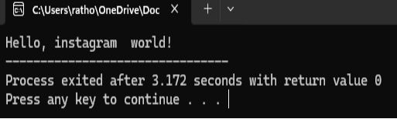

Question :-3 Identify and label the header, main function, and return statement in your hello.c program using comments.
Answer :-
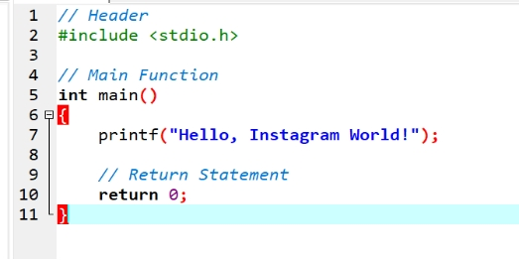
Question :-4 Compile your hello.c file using the GCC command line (gcc hello.c -o hello) and run the output file to display the message in your terminal.<br><br><em><strong>Hint:</strong> On Windows, the output file will be hello.exe; on Linux/Mac, it will be hello.</em>
Answer :-
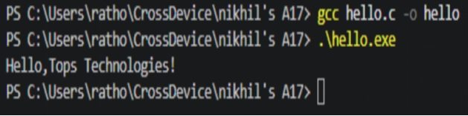

Session:-3
Question :-1 Declare variables for a Flipkart product: productName (as a string), price (float), and rating (double). Assign sample values and print each variable with its data type.
Answer :-
Question :-2 Create a constant variable to store the GST rate (for example, 18%) and use it to calculate the final price of a Zomato order with a given base price.<br><br><em><strong>Constraint:</strong> The GST rate must not be changeable after its initial assignment.</em>
Answer :-
Question :-3 Write a program that stores your favorite Spotify playlist's name (string), total number of songs (int), and average song duration in minutes (float). Print all values in a single formatted sentence.
Answer :-

Question :-4 Identify and correct the invalid variable names from this list: 1stPlayer, player_age, $score, total-marks, userName.<br><br><em><strong>Hint:</strong> Apply standard variable naming rules for your programming language.</em>
Answer:-

Given name | Valid/Invalid | Correct name
1stPlayer | Invalid | firstPlayer
player_age | Valid | player_age
$score | Invalid | score
total-marks | Invalid | total_marks
userName | Valid | userName

Session:-4

Question :-1.Create a simple JavaScript function called calculateTotal that takes two numbers: itemPrice and quantity, and returns the total bill amount using arithmetic operators.
Answer :-
Question :-2. Build a Flipkart-style discount calculator: given product price, discount percentage, and a boolean isMember, use arithmetic and logical operators to calculate the final price (apply an extra 5% off if isMember is true).
Answer :-
Question :-3. Write a function isEligibleForOffer that takes a user's age and total order value, and returns true if the user is 18 or older AND the order value is above 500, otherwise false.<br><br><em><strong>Hint:</strong> Use relational and logical operators together.</em>
Answer :-
Question :-4. Given three variables: likes, comments, and shares (all numbers), write code to check if a post is 'trending' on Instagram (at least 1000 likes OR more than 200 comments AND at least 50 shares). Print the result.
Answer :-

Question :-5. Write a code snippet that demonstrates the difference between pre-increment (++count) and post-increment (count++) by logging the values before and after using both on a followerCount variable.
Answer :-
:- ++followerCount → Increment first, then use
:- followerCount++ → Use first, then increment
Session:-5

Question :-1. Create a simple IPL Fan Bot that takes your favorite IPL team name as input and uses if-else-if statements to print a unique cheer message for each team (e.g., 'Go Mumbai Indians!', 'Chennai Super Kings for the win!'). If the team is not recognized, print 'Team not found!'
Answer :-

Question :-2. Build a Zomato-style food suggestion tool: take the user's preferred meal time ('breakfast', 'lunch', 'dinner', or 'snack') and use a switch-case statement to suggest a popular dish for that time. If the input doesn't match any meal, suggest 'Try some fruits!'.
Answer :-

Question :-3. Create a Flipkart discount calculator that asks the user for the total cart amount. Use nested if statements to check: if amount > 2000, apply 20% discount; else if amount > 1000, apply 10% discount; else, no discount. Print the final amount to pay.<br><br><em><strong>Hint:</strong> Use nested ifs to check each discount slab.</em>
Answer :-

Question :-4. Write a program that takes a user's age and checks eligibility for three things using if-else statements: if age >= 18, print 'Eligible for Driving License'; if age >= 21, also print 'Eligible for Credit Card'; if age >= 25, also print 'Eligible for Car Rental'. Print all applicable messages for the given age.
Answer :-
Session:-6

Question :-1. Write a program that prints the numbers from 10 down to 1 using a for loop, similar to a countdown timer.
Answer :-

Question :-2. Create a menu-driven console app that lets the user: 1) View your favorite 3 IPL teams, 2) Add a new team, 3) Exit. Use a while loop to keep showing the menu until the user chooses Exit.<br><br><em><strong>Hint:</strong> Use input() (or Scanner in Java) to get the user's choice each time.</em>
Answer :-

Question :-3. Build a 'Guess the Song' game like Spotify — the program randomly picks a song name from a list and asks the user to guess it. Use a do-while loop so the user can keep guessing until they get it right.<br><br><em><strong>Constraint:</strong> Use at least 3 song names of your choice.</em>
Answer :-

Question :-4. Explain with your own example the difference between entry-controlled and exit-controlled loops by writing a short code snippet for each (for/while vs do-while) and describing what happens if the loop condition is false at the start.
Answer :-
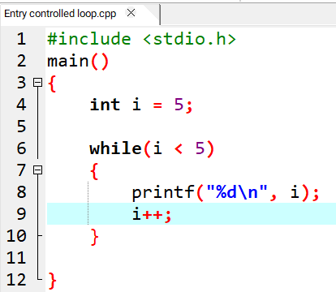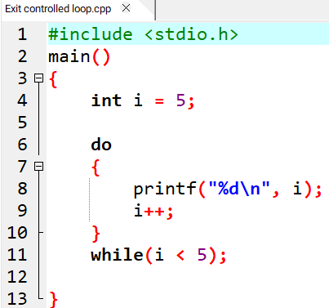

Difference:
Entry-Controlled Exit-Controlled
:-Condition is checked first :- Condition is checked at the end
:-for, while :- do-while
:-May execute 0 times :- Executes at least 1 time

Session:-7

Question :-1. Use nested for loops to print a grid of emojis representing a 5x5 Instagram post feed, where each cell shows a 📷 symbol.
Answer :-

Question :-2. Build a right-angled triangle pattern using nested loops, where each row displays increasing numbers starting from 1, similar to how a leaderboard on a gaming app shows rank numbers.
Answer :-

Question :-3. Create a pattern that prints a pyramid of stars (*) with 6 rows, centered like the loading animation you see on BookMyShow when a page is loading.<br><br><em><strong>Hint:</strong> Use spaces to align the stars in the center for each row.</em>
Answer :-

Question :-4. Write code using nested loops to print a pattern of alternating 0s and 1s in a grid, like the checkered background seen in some Spotify playlist covers (e.g., for a 4x4 grid, alternate 0 and 1 in each cell).
Answer :-

Question :-5. Modify your pyramid pattern code to accept the number of rows as user input, so the user can set the height of the pyramid before printing.
Answer :-
Session:-8
Question :-1.Declare a function called getUserInitials that takes a user's full name (like 'Virat Kohli') and returns their initials in uppercase (e.g., 'VK'). Call this function with your favorite cricketer's name and print the result.
Answer:-

Question :-2.Create a function addToCart that takes a shopping cart array and a product name, adds the product to the cart, and prints the updated cart. Demonstrate how passing the cart array by reference allows changes to persist outside the function.<br><br><em><strong>Hint:</strong> In languages like JavaScript, arrays are passed by reference. In C/C++, use pointers for reference behavior.</em>
Answer:-

Question :-3.Write two functions: increaseFollowersByValue and increaseFollowersByReference. Each should take a followers count and add 1000 to it, but one should use pass-by-value and the other pass-by-reference. Show how the original followers count changes (or doesn't) after calling each function.
Answer:-

Question :-4.Build a function formatPrice that takes a price in rupees and returns a string formatted like Flipkart's price tag (e.g., '₹1,599'). Use this function to display prices for three different products.
Answer:-

Question :-5.Refactor an existing function you wrote above to make it reusable for both product names and usernames (for example, a function that capitalizes the first letter of any string).<br><br><em><strong>Constraint:</strong> The refactored function should work for any string input, not just a specific use case.</em>
Answer:-
Session:-9
Question :-1.Declare a 1D array called dailySteps with 7 elements to store your step count for each day of the week, assign sample values, and print each value using a loop.
Answer:-

Question :-2.Create a 2D array called playlistRatings to store ratings for 3 Spotify playlists over 5 days (rows = playlists, columns = days). Fill it with sample numbers and print the ratings for the second playlist.
Answer:-

Question :-3.Build a function that takes a 1D array of 7 integers representing your daily Zomato order amounts and calculates the average spend for the week.<br><br><em><strong>Hint:</strong> Use a loop to sum the values, then divide by the array length.</em>
Answer:-

Question :-4.Given a 2D array called cricketScores where each row represents an IPL match and columns represent runs scored by each team, write code to print the highest score from each match.
Answer:-

Session:-10
Question :-1.Declare a string variable called songTitle and assign it the value 'Tum Hi Ho'. Print the length of the string using strlen().
Answer:-

Question :-2.Take input for two usernames (as strings) and compare them using strcmp(). Display whether they are the same or different.
Answer:-

Question :-3.Copy the string 'Flipkart' into another string variable called shoppingApp using strcpy(), then print the value of shoppingApp.<br><br><em><strong>Hint:</strong> Make sure to declare enough space for the destination string.</em>
Answer:-

Question :-4.Build a small script that takes the user's full name as input and creates a username by copying only the first 5 characters using strcpy(). Print the generated username.<br><br><em><strong>Constraint:</strong> If the name is shorter than 5 characters, use the full name as the username.</em>
Answer:-
Session:-11
Question :-1.Declare an integer variable called likes and a pointer variable called ptrLikes; assign likes a value, point ptrLikes to likes, and print both the value and the address stored in ptrLikes.
Answer:-

Question :-2.Write a function swapPlaylistCounts(int *a, int *b) that swaps the number of songs in two Spotify playlists using pointers, then call the function in main and print the swapped values.
Answer:-

Question :-3.Given an array of 5 order amounts (e.g., Zomato orders), use a pointer to iterate through the array and print each amount along with its memory address.<br><br><em><strong>Hint:</strong> Use pointer arithmetic to move to the next element.</em>
Answer:-

Question :-4.Create a function incrementFollowers(int *followers, int n) that increases each follower count in an array (representing Instagram followers for 5 friends) by 100 using pointer arithmetic, then print the updated counts.
Answer:-

Question :-5.Draw a simple memory diagram (on paper or using any drawing tool) showing how a pointer references the address of a variable, using the variables from your likes and ptrLikes example; label the variable, pointer, and address.
Answer:-
📦 likes
┌─────────┐
│ 1000 │
└────┬────┘
│
│ address
▼
┌─────────┐
│ 2000 │
└────▲────┘
│
points to
│
┌─────────┐
│ptrLikes │
│ 2000 │
└─────────┘

Session:-12
Question :-1.Declare a structure named Playlist to store details of a song: title (string), artist (string), and duration in seconds (integer). Initialize one Playlist variable with your favorite song's details and print each field.
Answer:-

Question :-2.Create a structure called FoodItem to store Zomato-style menu data: itemName (string), price (float), and rating (float). Initialize an array of 3 FoodItem variables with real menu items and display their details using a loop.
Answer:-

Question :-3.Define a nested structure called MovieShow for a BookMyShow-style app: Movie (string), Screen (integer), and a nested structure Time with hours and minutes (integers). Create and initialize a MovieShow variable for any movie and print its details in the format 'Movie: X, Screen: Y, Time: HH:MM'.
Answer:-

Question :-4.Build a structure called InstaProfile with fields: username (string), followers (integer), and a nested structure Bio with fields: description (string) and age (integer). Initialize an InstaProfile variable with your own details and display all fields.
Answer:-
Session:-13
Question :-1.Create a file called playlist.txt and write the names of your top 3 favorite songs from Spotify into it using write mode (w).
Answer:-

Question :-2.Open playlist.txt in read mode (r) and display each song name on a separate line in the console.
Answer:-

Question :-3.Add two more song names to playlist.txt without deleting the existing ones by opening the file in append mode (a).
Answer:-

Question :-4.Write a program that reads all song names from playlist.txt and prints only those that contain the word 'love' (case-insensitive).<br><br><em><strong>Hint:</strong> Use the 'in' keyword or equivalent string method for filtering.</em>
Answer:-

Session:-14
Question :-1.Given the following buggy code meant to calculate the total price of a Zomato order, identify and fix the syntax and runtime errors:<br><br>let items = ["Burger", "Pizza", "Fries"];<br>let prices = [120, 250, 90];<br>let total = 0;<br>for (i = 0; i < items.length; i++) {<br> total =+ prices[i]<br>}<br>console.log("Total price is: " + total);<br><br><em><strong>Hint:</strong> Watch for assignment and loop variable issues.</em>
Answer:-

Question :-2.Rewrite the following code to improve its indentation and add comments explaining each step, so that a beginner can understand what it does:<br><br>function isEven(num){if(num%2==0){return true;}else{return false;}}
Answer:-

Question :-3.Write a function formatFollowersCount(count) that takes a number and returns a formatted string like Instagram: 1500 as '1.5K', 1200000 as '1.2M', and numbers below 1000 as-is. Add clear comments and use proper indentation.
Answer:-

Question :-4.You are given a piece of JavaScript code that should print all even numbers from 1 to 10, but it doesn't work as expected:<br><br>for (let i = 1; i <= 10; i++) {<br> if (i % 2 = 0) {<br> console.log(i)<br> }<br>}<br><br>Find and fix the error, then rewrite the code with good indentation and at least one comment explaining the logic.
Answer:-

Mini project :-1
Question :-1.Create a console-based app called Music Listening Logger that allows users to enter the number of minutes they listened to music each day for a week and stores this data in an array
Answer:-

Question :-2.Add a menu-driven interface to your Music Listening Logger so users can choose to log new listening minutes, view their weekly summary, or exit the app.<br><br><em><strong>Hint:</strong> Use a loop to repeatedly show the menu until the user selects exit.</em>
Answer:-

Question :-3.Implement file handling in your Music Listening Logger so that when the user logs their daily listening minutes, the data is saved to a file named music_log.txt for persistence.
Answer:-

Question :-4.Add a feature to your app that reads the saved music_log.txt file and generates a weekly report showing the total, average, and highest listening minutes in the week.
Answer:-

Question :-5.Refactor your Music Listening Logger to allow users to reset their weekly data by clearing the array and deleting the contents of music_log.txt.<br><br><em><strong>Constraint:</strong> Make sure the reset option is available in the menu and asks for confirmation before deleting data.</em>
Answer:-

